**ST. XAVIER’S COLLEGE**

**(Affiliated to Tribhuvan University)**

Maitighar, Kathmandu



**COMPUTER GRAPHICS**

**LAB ASSIGNMENT#7**

**Submitted by:**

Shreesha Pokharel

013BSCCSIT038

**Submitted to:**

|  |  |
| --- | --- |
| **Er. Anil K. Sah** |  |

Lecturer

Department of Computer Science

Date of submission: 1st September, 2015

**STATEMENT: IMPLEMENTATION OF TRANSLATION, ROTATION AND SCALING.**

Source code:

//---------------------------------------------------------------------------

#include <math.h>

#include <vcl\vcl.h>

#pragma hdrstop

#include "Unit1.h"

//---------------------------------------------------------------------------

#pragma resource "*.dfm"

TForm1 *Form1;

int x,y,i,j,a,b;

//---------------------------------------------------------------------------

__fastcall TForm1::TForm1(TComponent* Owner)

: TForm(Owner)

{

}

//---------------------------------------------------------------------------

//---------------------------------------------------------------------------

//---------------------------------------------------------------------------

void __fastcall TForm1::translateClick(TObject *Sender)

{

x=Image1->Height;

y=Image1->Width;

for(i=0;i<=x;i++)

{

for(j=0;j<=y;j++)

{

a=i+StrToInt(Edit1->Text);

b=j+StrToInt(Edit2->Text);

Image2->Canvas->Pixels[a][b]=Image1->Canvas->Pixels[i][j];

}

}

}

//---------------------------------------------------------------------------

void __fastcall TForm1::Button2Click(TObject *Sender)

{

x=Image1->Height;

y=Image1->Width;

for(i=0;i<=x;i++)

{

for(j=0;j<=y;j++)

{

a=i*StrToInt(Edit4->Text);

b=j*StrToInt(Edit5->Text);

Image2->Canvas->Pixels[a][b]=Image1->Canvas->Pixels[i][j];

}

}

}

//---------------------------------------------------------------------------

void __fastcall TForm1::Button1Click(TObject *Sender)

{

x=Image1->Height;

y=Image1->Width;

for(i=0;i<=x;i++)

{

for(j=0;j<=y;j++)

{

a=100+i*cos(StrToInt(Edit3->Text))-j*sin(StrToInt(Edit3->Text));

b=100+i*sin(StrToInt(Edit3->Text))+j*cos(StrToInt(Edit3->Text));

Image2->Canvas->Pixels[a][b]=Image1->Canvas->Pixels[i][j];

}

}

}

//---------------------------------------------------------------------------

**Translation:**

**Input:**

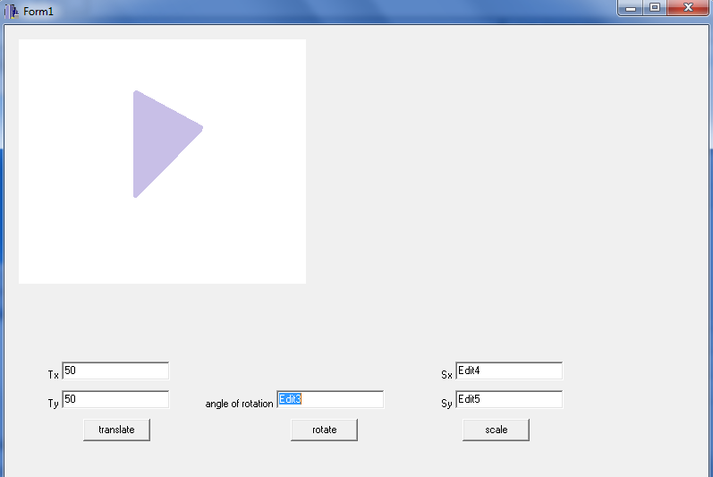

**Output:**

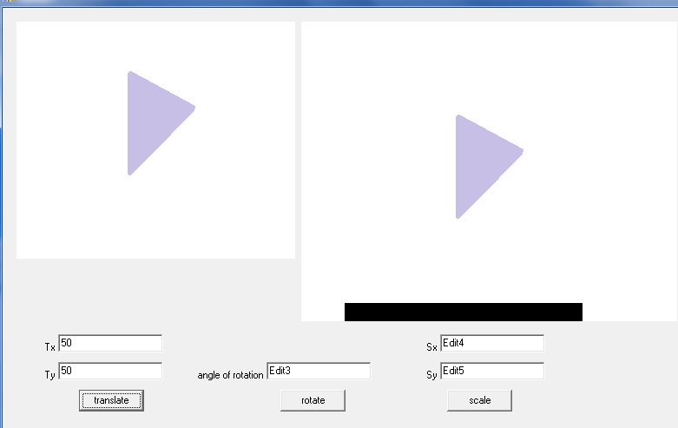

**Rotation:**

**Input:**

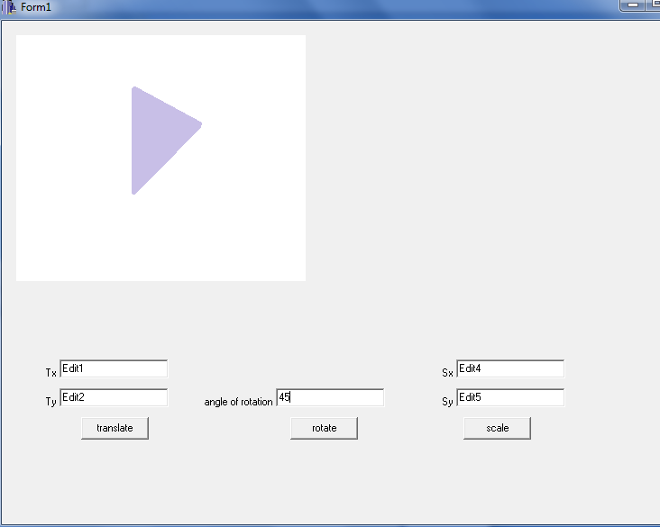

**Output:**

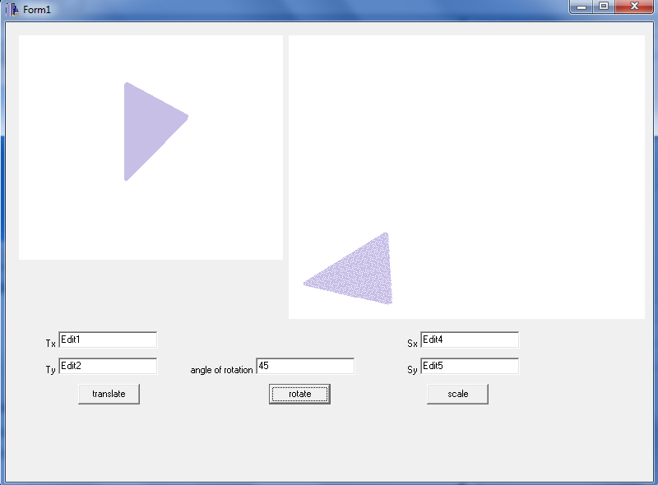

**Scaling:**

**Input:**

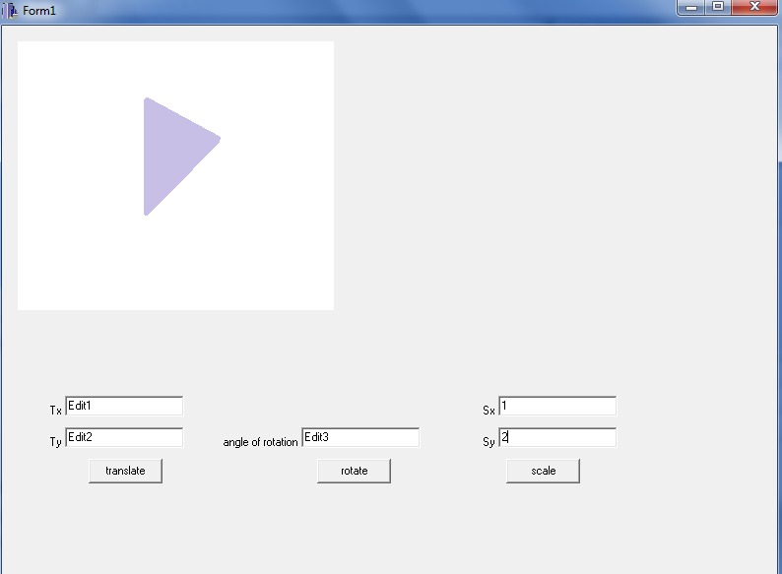

**Output:**

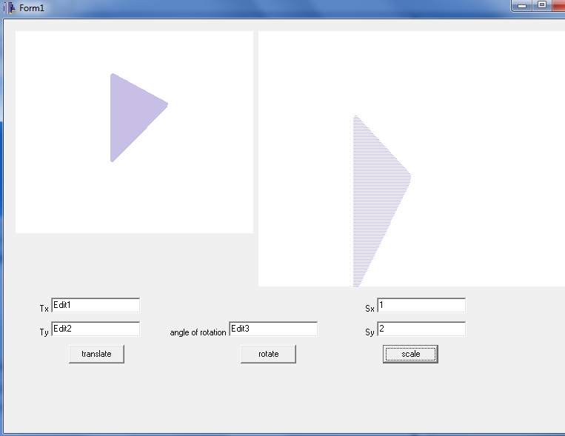

**Conclusion:**

Therefore, translation, rotation and scaling were implemented as shown.

**Reference:**

[1] D. Hearn and M. Baker, Computer Graphics, second edition.